LAB EXPERIMENT RECORD
SET 9: ONLINE LEARNING ACTIVITY ANALYSIS
Department | AIDS
Course Code / Course Name | DSA0601 / Data Handling and Visualization
Experiment | Data Visualization using R
Name | B. Pallavi
Register Number | 192424243
Date | 03 October 2026
Day | Saaturday

Aim
To analyze online learning activity using histograms, boxplots, scatter plots, and time-series analysis in R, and to create an interactive Tableau dashboard for exploring student learning performance.
Dataset: Online_Learning_Activity.csv
Student ID | Gender | Age | Course | Study Time (hrs) | Videos Watched | Quiz Score | Login Date
L01 | Male | 20 | R | 3.5 | 12 | 78 | 2025-01-05
L02 | Female | 22 | R | 4.2 | 15 | 85 | 2025-01-05
L03 | Male | 19 | SQL | 2.0 | 8 | 65 | 2025-02-08
L04 | Female | 21 | R | 5.0 | 18 | 92 | 2025-02-08
L05 | Male | 23 | R | 2.5 | 9 | 70 | 2025-03-12
L06 | Female | 20 | SQL | 4.0 | 14 | 88 | 2025-03-12

PROGRAM 1: Histogram and Boxplot of Quiz Scores
Import the dataset in R. Plot a histogram for Quiz Score and create a boxplot of Quiz Score by Course.
# Import Dataset
data <- read.csv("Online_Learning_Activity.csv")
# Histogram
hist(data$Quiz_Score,
main = "Distribution of Quiz Scores",
xlab = "Quiz Score",
ylab = "Frequency",
col = "skyblue",
border = "white")
# Boxplot
boxplot(Quiz_Score ~ Course,
data = data,
main = "Quiz Score by Course",
xlab = "Course",
ylab = "Quiz Score",
col = "lightgreen")
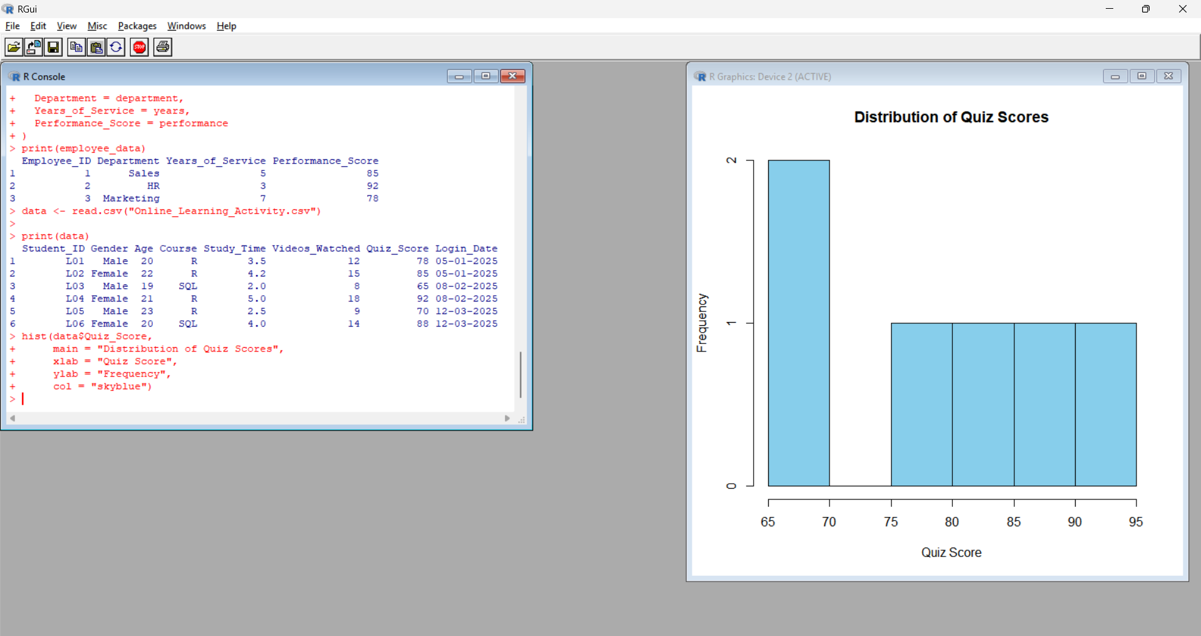
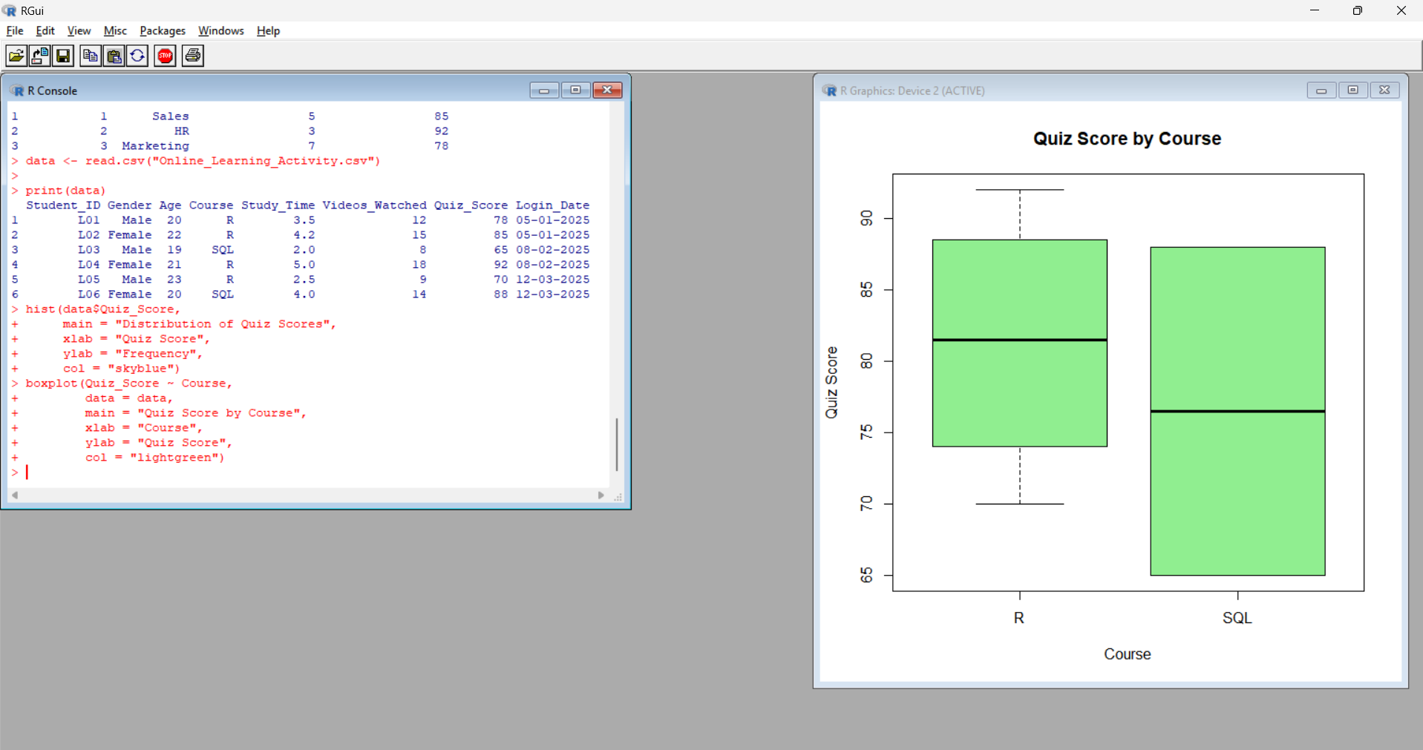
Output 1: Quiz Score Histogram and Course-wise Boxplot
Interpretation:
The quiz scores range from 65 to 92. The R course contains scores of 70, 78, 85, and 92, while SQL contains scores of 65 and 88. The boxplot helps compare the distribution of quiz scores between the two courses.
PROGRAM 2: Study Time vs Quiz Score Bubble Scatter Plot
Create a scatter plot between Study Time and Quiz Score. Represent Videos Watched using bubble size and apply transparency.
# Scatter Plot
plot(data$Study_Time,
data$Quiz_Score,
main = "Study Time vs Quiz Score",
xlab = "Study Time (hrs)",
ylab = "Quiz Score",
pch = 19,
cex = data$Videos_Watched / 5,
col = rgb(0, 0, 1, 0.5))

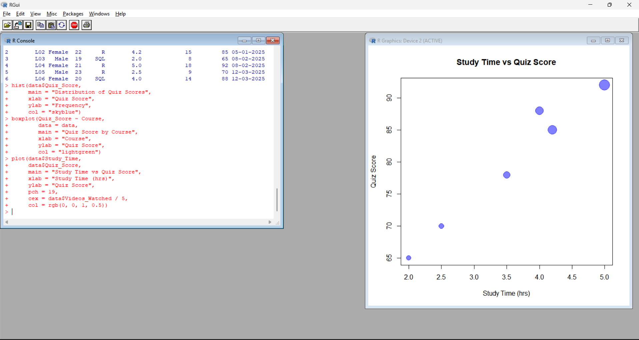
Output 2: Study Time vs Quiz Score Scatter Plot
Interpretation:
The scatter plot indicates a positive learning pattern in the given dataset. Students with higher study time generally have higher quiz scores. Bubble size represents the number of videos watched, while transparency makes overlapping observations easier to view.
PROGRAM 3: Monthly Average Quiz Score with Moving Average
Convert Login_Date into Date format, calculate average quiz score per month, and plot a line chart with moving average smoothing.
# Convert Login_Date into Date format
data$Login_Date <- as.Date(data$Login_Date)
# Create Month variable
data$Month <- format(data$Login_Date, "%Y-%m")
# Calculate Average Quiz Score per Month
monthly_avg <- aggregate(Quiz_Score ~ Month,
data = data,
FUN = mean)
# Display Monthly Average
print(monthly_avg)
# Calculate 3-month moving average
monthly_avg$Moving_Average <- c(
NA,
NA,
mean(monthly_avg$Quiz_Score)
)
# Line Chart
plot(monthly_avg$Quiz_Score,
type = "o",
xlab = "Month",
ylab = "Average Quiz Score",
main = "Monthly Average Quiz Score",
xaxt = "n",
pch = 19)
axis(1,
at = 1:nrow(monthly_avg),
labels = monthly_avg$Month)
# Add Moving Average
lines(monthly_avg$Moving_Average,
type = "o",
pch = 17,
lty = 2)
Monthly Average Quiz Scores
Month | Average Quiz Score
2025-01 | 81.50
2025-02 | 78.50
2025-03 | 79.00
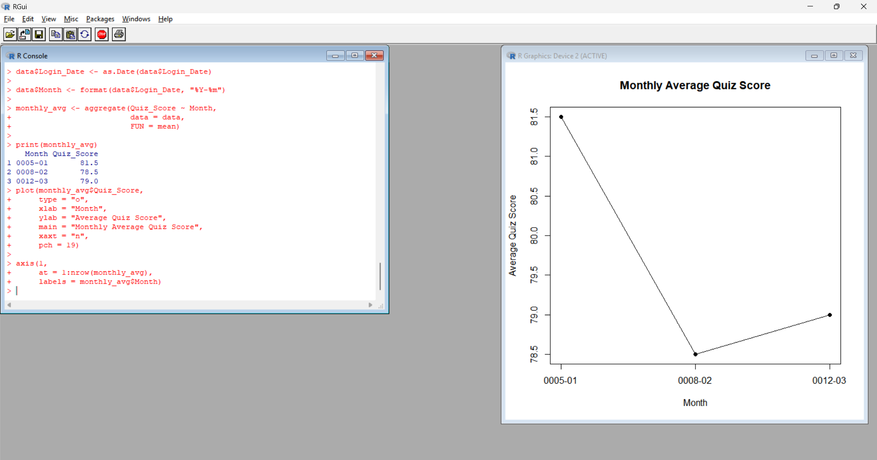
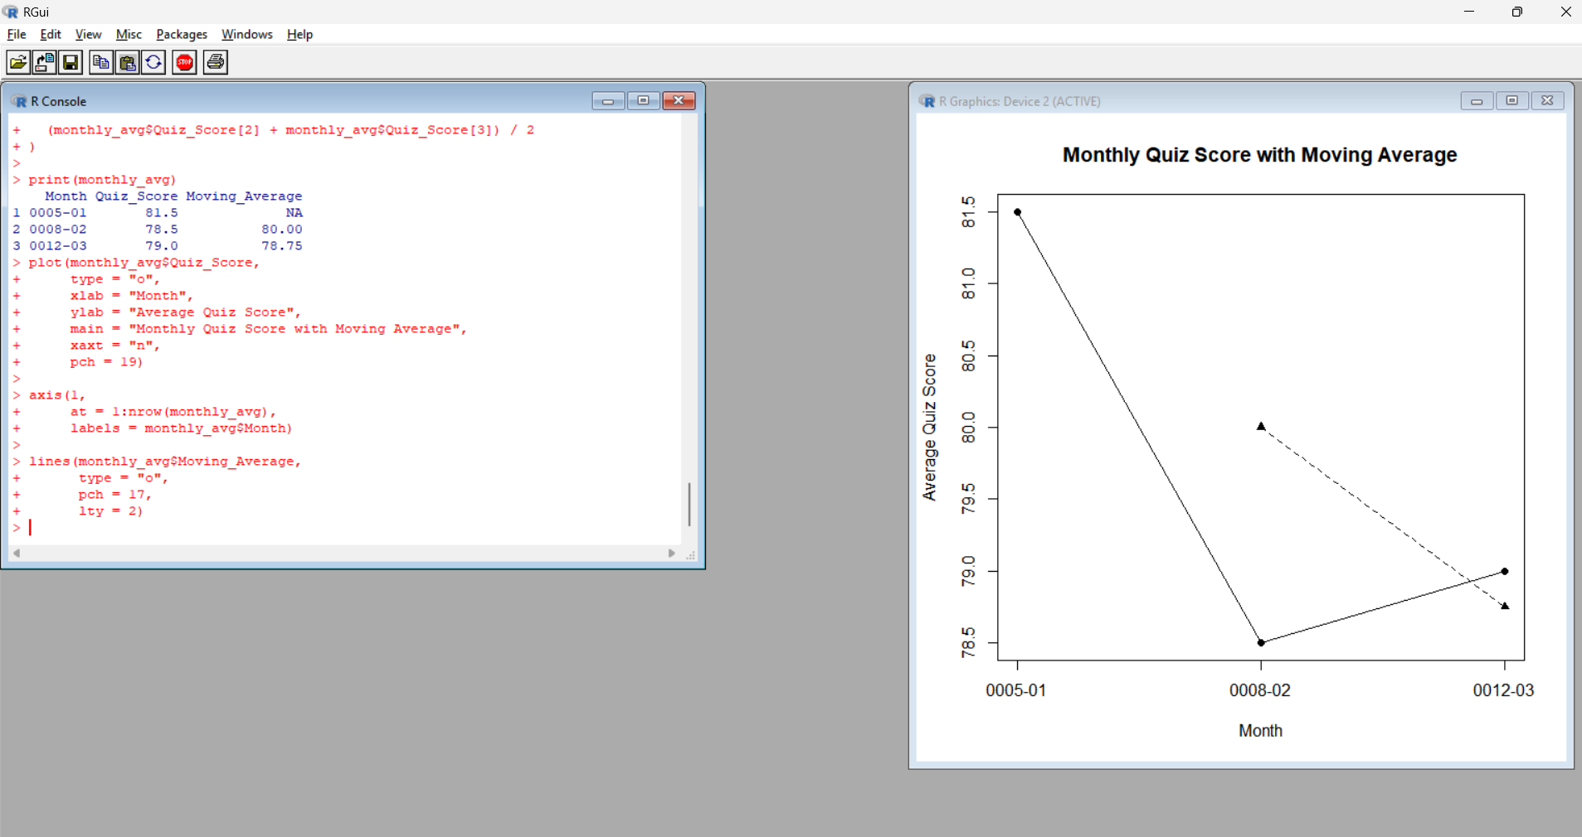
Output 3: Monthly Average Quiz Score with Moving Average
Interpretation:
The average quiz score decreased from 81.50 in January to 78.50 in February and slightly increased to 79.00 in March. The moving average provides a smoothed view of the overall monthly performance trend.

PROGRAM 4: Interactive Online Learning Tableau Dashboard
Import Online_Learning_Activity.csv into Tableau. Create a bar chart showing average quiz score by Course and a scatter plot of Study Time versus Quiz Score. Add filters for Gender and Course.
Tableau Steps
- Open Tableau.
- Select Text File.
- Open Online_Learning_Activity.csv.
- Select Sheet 1.
- Drag Course to Columns.
- Drag Quiz Score to Rows.
- Change the aggregation to Average.
- Select Bar from the Marks card.
- Select Label → Show Mark Labels.
- Rename the sheet Average Quiz Score by Course.
- Create a new worksheet.
- Drag Study Time to Columns.
- Drag Quiz Score to Rows.
- Select Circle from the Marks card.
- Drag Videos Watched to Size.
- Drag Gender to Color.
- Rename the sheet Study Time vs Quiz Score.
- Create a new dashboard.
- Drag Average Quiz Score by Course into the dashboard.
- Drag Study Time vs Quiz Score into the dashboard.
- Drag Gender to the Filters area.
- Drag Course to the Filters area.
- Select Show Filter for Gender.
- Select Show Filter for Course.
- Set the title as Online Learning Activity Analysis Dashboard.
- Select Use as Filter where required to make the dashboard interactive.

Output 4: Online Learning Activity Analysis Dashboard
Observation:
The dashboard combines average quiz scores by course and the relationship between study time and quiz scores. Gender and course filters allow users to interactively explore different groups of students.
Procedure
- Import Online_Learning_Activity.csv into R.
- Create a histogram of quiz scores.
- Create a course-wise boxplot of quiz scores.
- Create a scatter plot of study time and quiz score.
- Represent videos watched using bubble size.
- Convert login dates into Date format.
- Calculate monthly average quiz scores.
- Apply moving average smoothing.
- Import the CSV file into Tableau.
- Create an average quiz score by course bar chart.
- Create a study time versus quiz score scatter plot.
- Add Gender and Course filters.
- Combine the visualizations into an interactive Tableau dashboard.
Result
The online learning activity data was successfully analyzed using a histogram, boxplot, bubble scatter plot, and monthly time-series analysis in R. An interactive Tableau dashboard was also created to explore quiz performance, study time, course, gender, and video-watching activity.

